**Bank Application**

Step 1: Login to the page

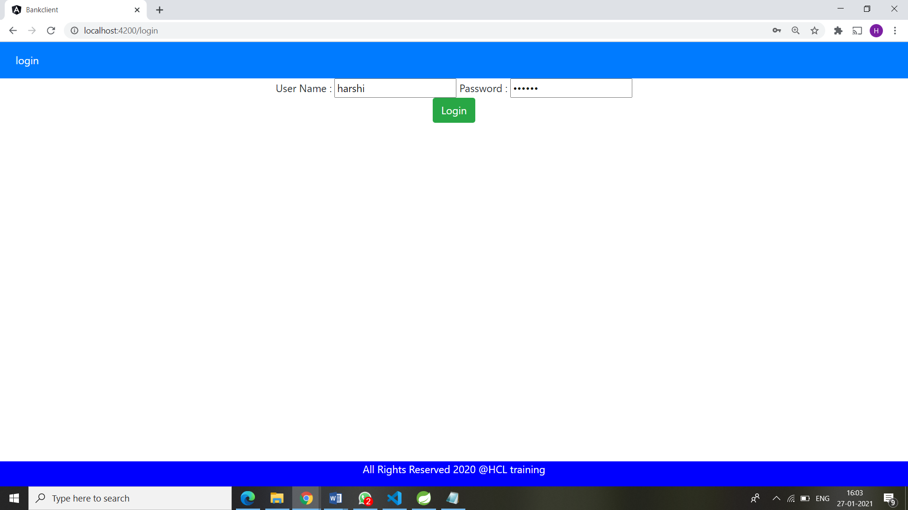

Step2: After Login, the accounts List will be displayed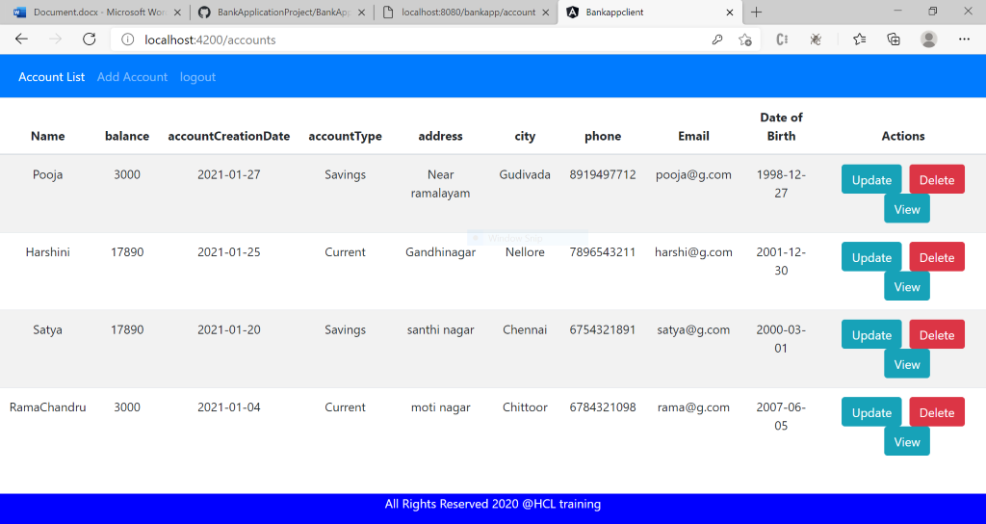

Step 3: Add account to the Accounts List

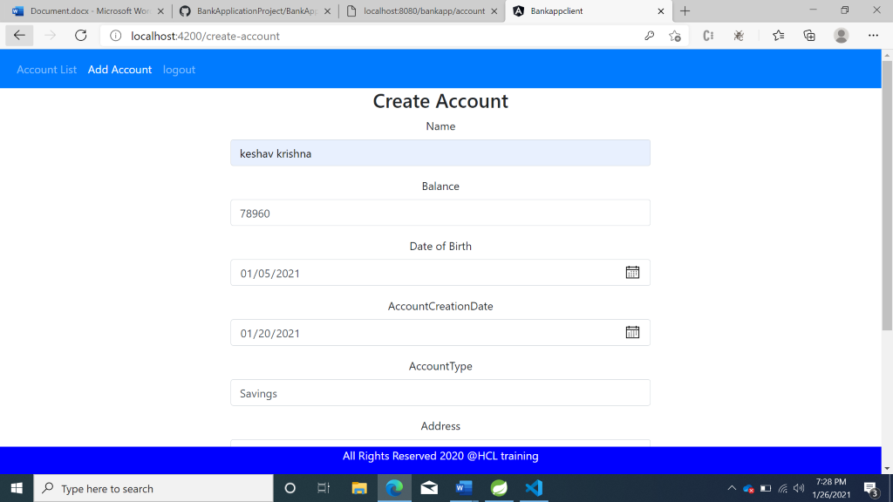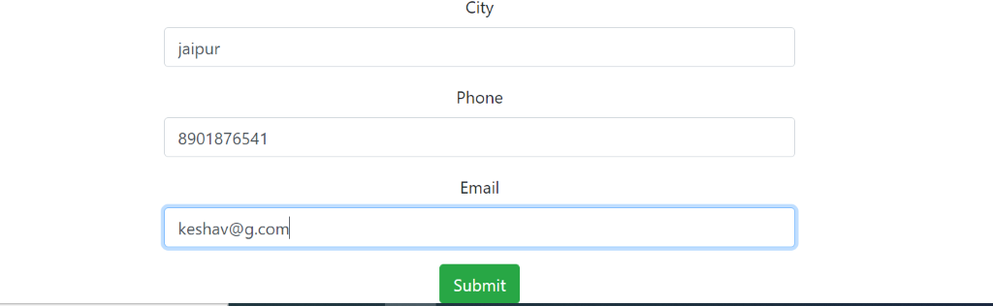



Step 4: After submitting in Add Account form, the total records are :

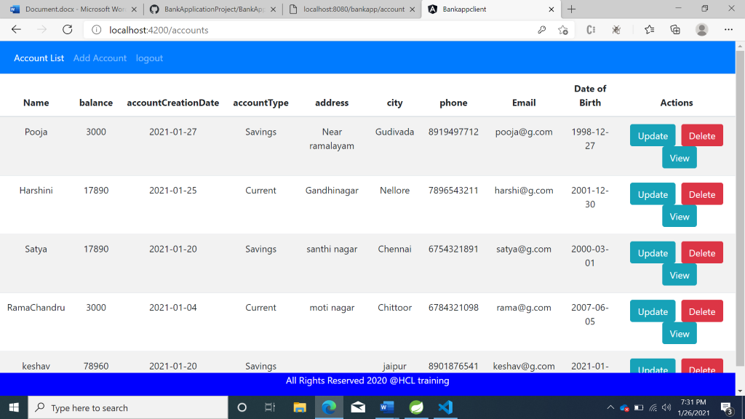

Step 5: Now, we can update the Account Details of Record named “Harshini” by clicking Update button. We are changing city from Nellore to Hyderabad.

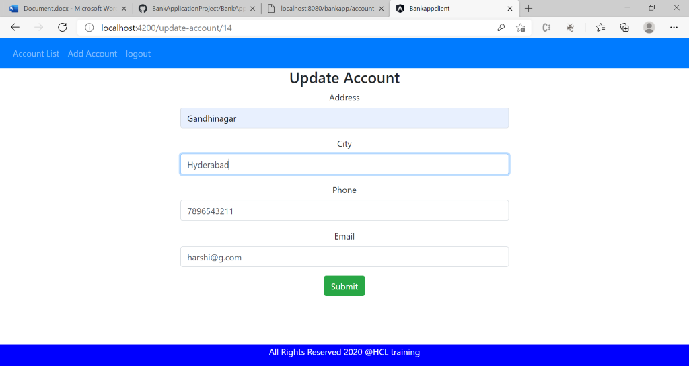

Step 6: After Update, the city is changed from Nellore to Hyderabad in record named Harshini

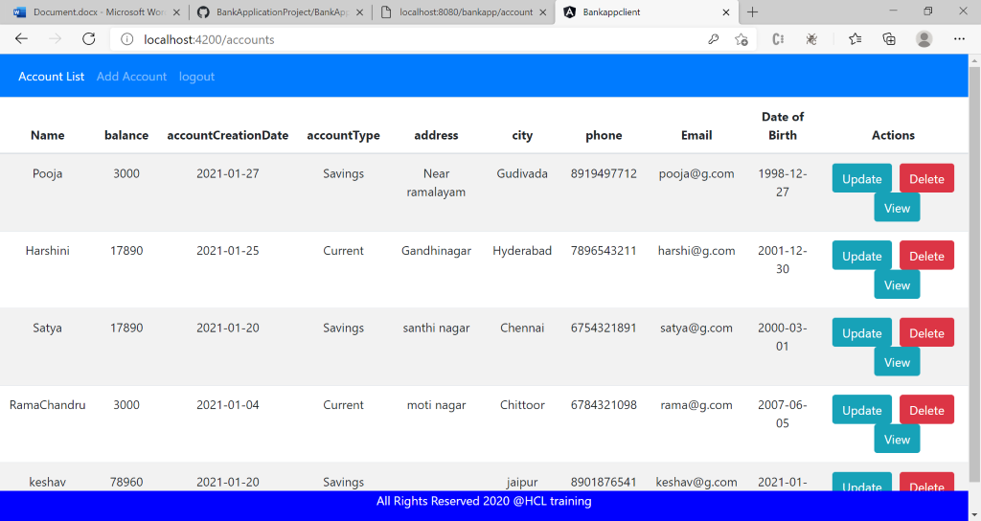

Step 7: Now, we can  delete the record named “satya” by clicking delete button.

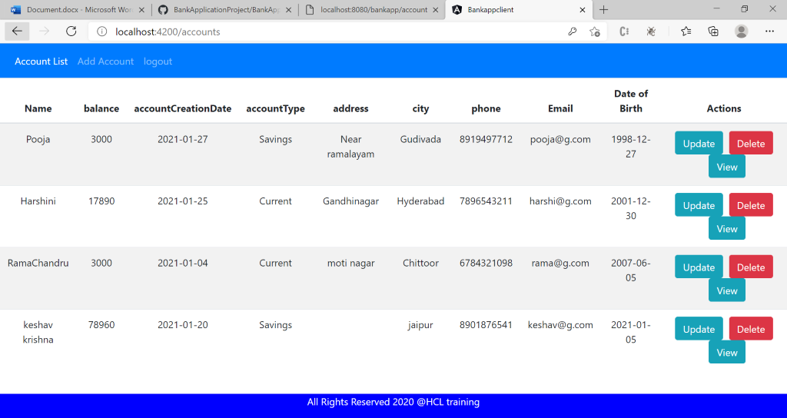

Step 8: Now, we can view the account details of record named “Harshini”  by clicking the view button

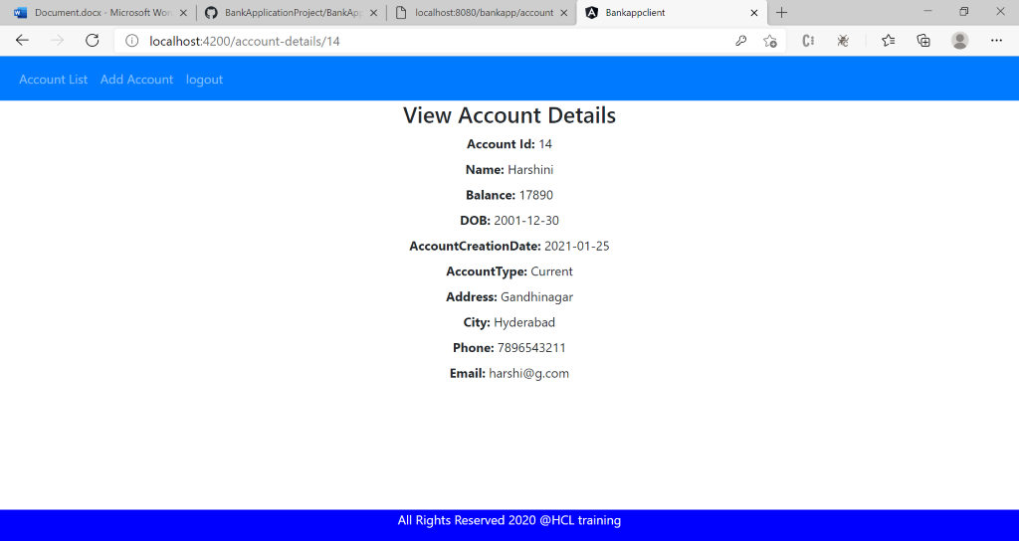

Step 9: After completing all the operations ,we can Logout from the page. Then, the page redirects to Login page.

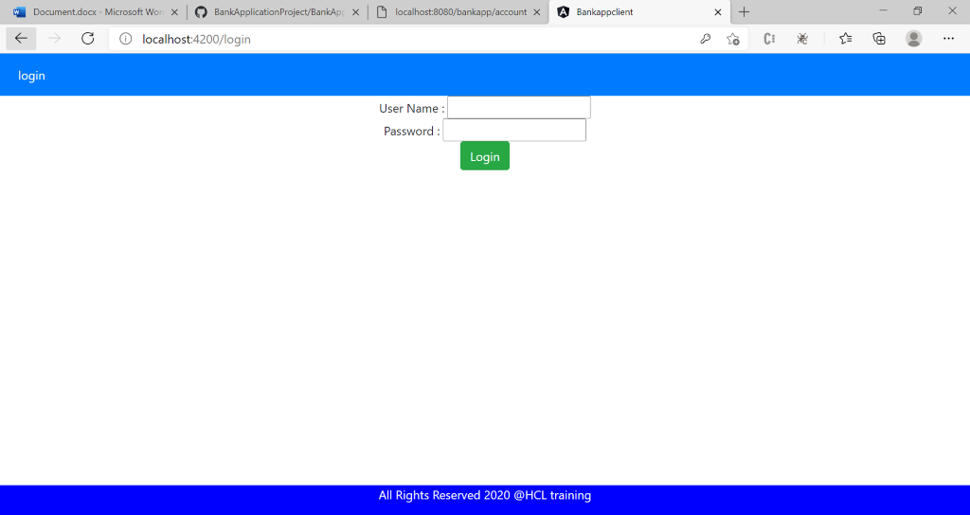

USECASE DIAGRAM:

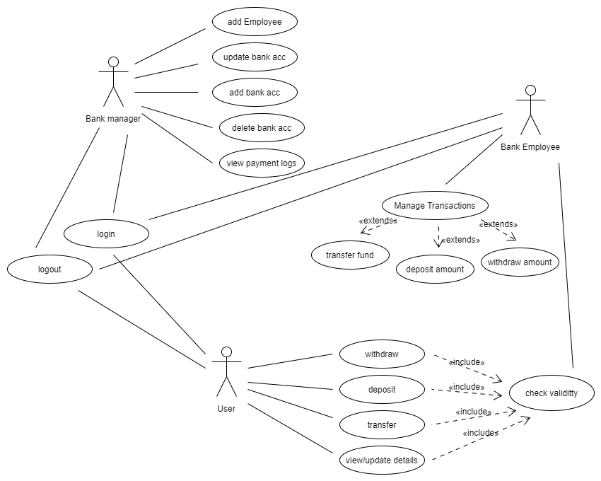

Class Diagram:

